12 ATAR Physics

Section B Questions 2016

**SECTION B: Problem Solving**

**Marks Allotted: 92 marks out of total of 180 marks (52%)**

This section contains 7 questions. You should answer **ALL** of the questions.

Answer all questions in the spaces provided.

15. [14 marks]

Tom is caught on a banked roundabout in East Perth. He is travelling at a steady speed and his situation is shown in the plan and side views below. The car’s speed is such that there is no sideways frictional force between the tyres and the road.

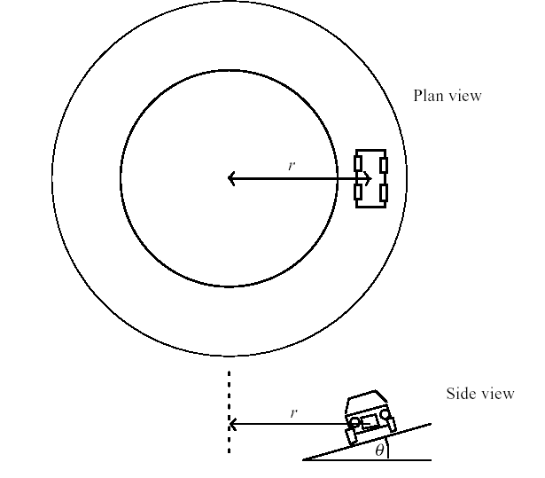(a) Does Tom's car have an acceleration?

Explain your answer.

[2 marks]

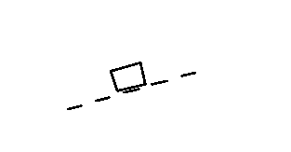(b) We could represent Tom's car on the roundabout by a block in the diagram below.  
  
  
On the diagram above, draw and label all the forces acting on the moving car?

[3 marks]

(c) Is there a resultant force acing on the car? Explain

[2 marks]  
  
  
  
  
  
(d) Why is it that engineers, when designing roundabouts and freeway off ramps, often bank them? Use a diagram to assist your answer.  
 [2 marks]

(e) Using any necessary assumptions, calculate the speed that the car must travel at in order for there to be no sideways frictional force between the tyres and the road? [3 marks]

(f) Suppose now that some oil had been spilled on the roundabout. What effect would this have on Tom's car if he maintained the speed you calculated in part (e)? Explain.

[2 marks]

16. [11 marks]

At the centre of the Milky Way is a black hole known as Sagittarius A*. It has a mass equivalent to 4.31 billion Suns. It is 26 500 light years from the Sun. A light year is the distance light would travel in one year.

(a) Calculate the gravitational force between the black hole and the Sun.

(3 marks)

(b) Using this force (from part a), to calculate the orbital speed of the Sun around the black hole. (3 marks)

(c) The Sun moves around the black hole (assume circular orbit) with a speed of

2.20 x 102 km s-1. Calculate the centripetal force involved in creating this orbit.

(2 marks)

(d) Compare the values of part (a) and (c). Explain why they are different.

(3 marks)

17. [17 marks]

The Perth Wildcats basketball team is two points down and Damien Martin has the ball in centre court. He puts up the shot and scores three points.

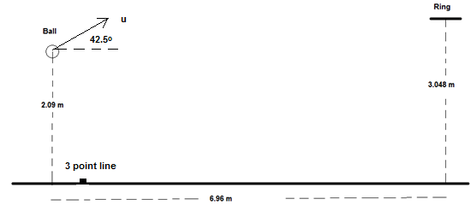

(a) In the space below, draw a diagram of the ball showing the force/s acting on it whilst in flight. Assume no air resistance. (2 marks)

(b) Martin propels the ball at an angle to the horizontal of 42.5o. What is the initial speed of the ball as shown in the diagram? (6 marks)

(c) Calculate the velocity as it passes through the ring in order to score the three points to win the game. (7 marks)

18. [11 marks]

A simple crane is used in a service station to lift engines (represented as load L) from cars and transfer them to a workbench. Rollers are used so that the mechanic can move the engine from one end of the beam to the other as shown in the diagram. The beam (B) is 2.50 m long, the support wire (S) is attached 0.50 m from the outer end at an angle of 35.0° to the beam.

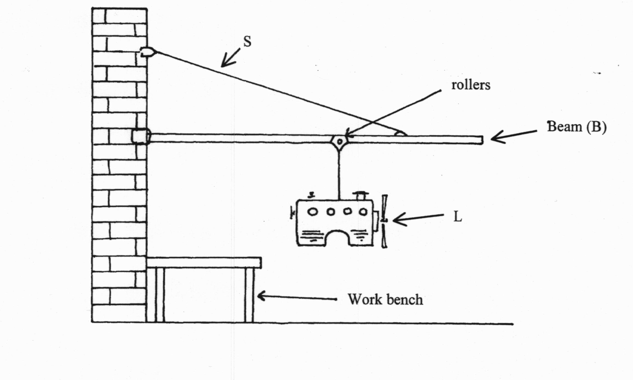

The beam is uniform and has a mass of 38.5 kg. The combined mass of the engine and the rollers is 165 kg. In the current position, the load is 1.50 m from the wall.

(a) On the diagram above, draw all of the forces acting with the load in the position shown.

[3 marks]

(b) Find the tension in the support cable “S”, when the engine is at the position shown.

[3 marks]

(c) Find the magnitude and direction of the reaction force that the wall exerts on the beam.

[5 marks]

19. [14 marks]

(a) A metal axle from a model railway train is propelled along two live rails as shown in the diagram below.

(i) For the axle to move in the direction shown, a magnetic field of intensity of

4.00 x 10-2 T is applied. ***Circle the direction/letter*** next to the arrow that indicates the direction of the magnetic field.

[2 marks]

(ii) The axle has a mass of 55.0 g and has a length of 4.00 cm. Find its acceleration if the current through the axle is 16.0 A.

[3 marks]

(iii) In fact, the acceleration is somewhat less than that calculated in part (iii). Suggest ***two*** reasons for this.

[2 marks]

•

•

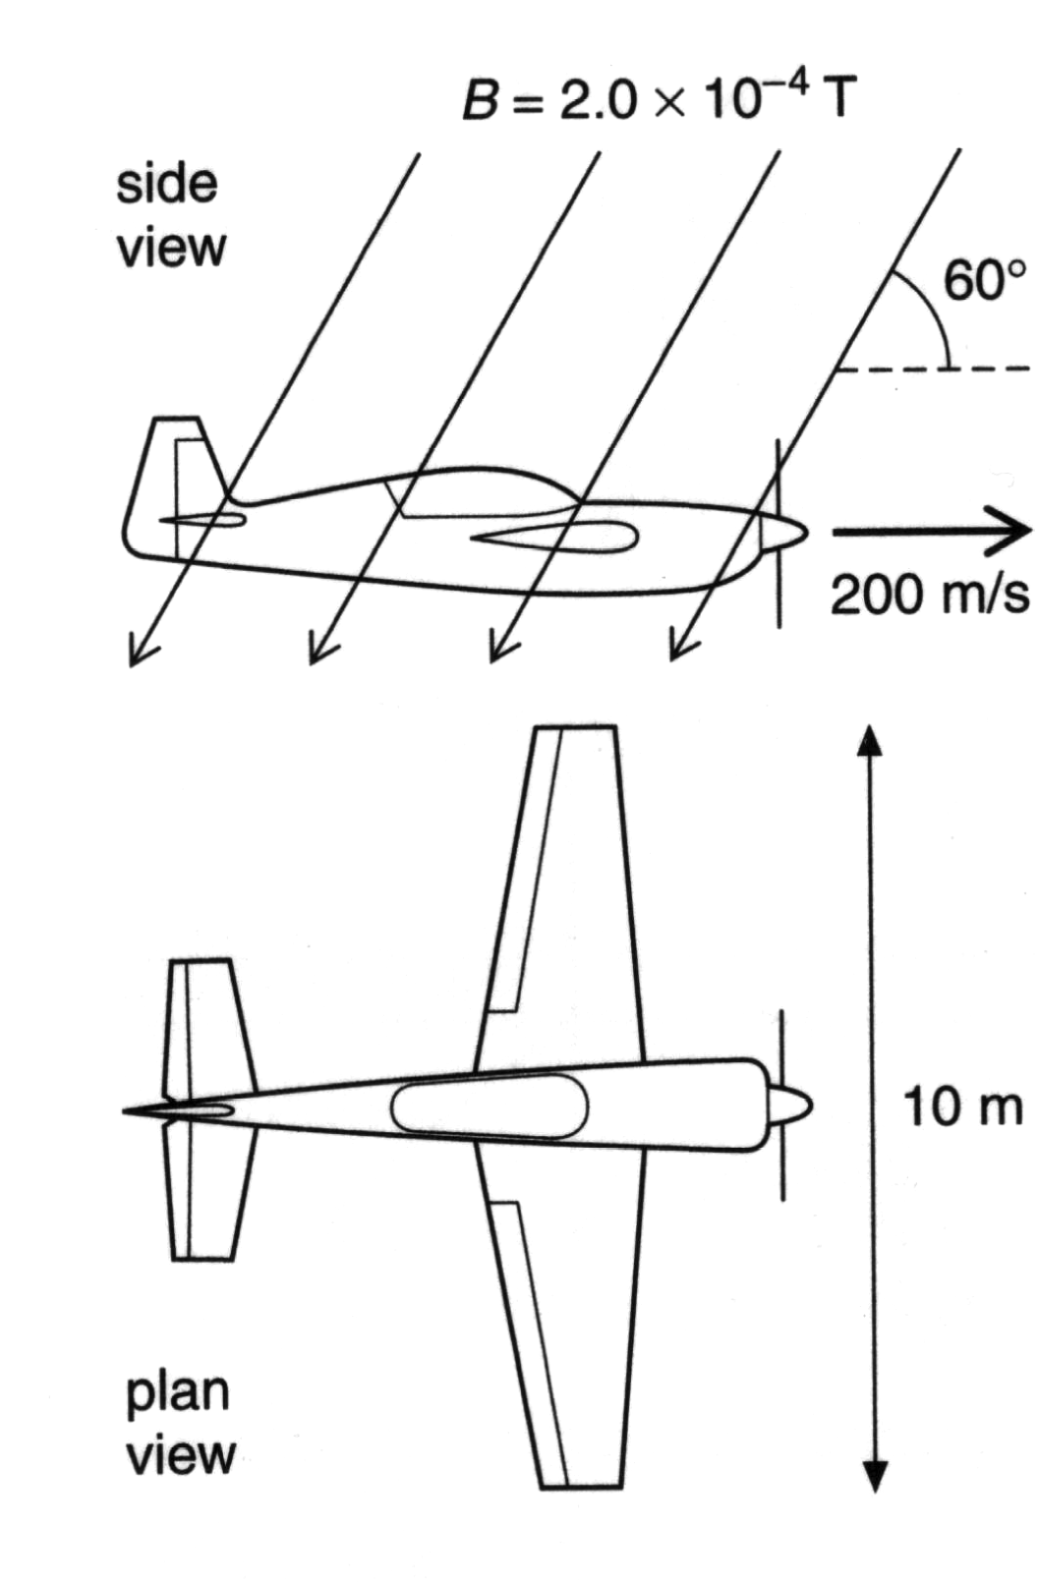(b) An aeroplane with a wingspan of 10.0 m is flying horizontally at a velocity of 2.00 x 102 ms-1 due north in the southern hemisphere. In the region the plane is flying, the Earth’s magnetic field is 2.00 x 10-4 T at an angle of 60.0° to the horizontal.

(i) Which component (horizontal or vertical) of the Earth’s magnetic field is used to calculate EMF across the wings?

[1 mark]

(ii) Find the size of this component of the field.

[2 marks]

(iii) Calculate the EMF is induced across the wingtips of the plane.

[2 marks]

(iv) Could this EMF be used to power the cabin lights? Explain your answer.

[2 marks]

20. [12 marks]

A mining company use an electric pump with an operating voltage in the range

1.25 kV-1.50 kV. There is only a 240 VRMS supply available. A transformer is used to step up the output voltage to 1.50 kVRMS. The secondary winding of the transformer has 2000 turns of wire.

Input

240 V

Output

1.50 kV

Electric Pump (Vd = 1.45 kV)

Cables

Transformer

(a) Calculate the number of turns required on the primary winding of the transformer. (2 marks)

The transformer has an electrical power output of 6.45 kW. The underground pump is connected by 1.10 km of cables to the surface. The potential difference across the pump is 1.45 kV.

(b) Calculate the total resistance of the cables. (4 marks)

(c) Calculate how much electrical energy per second is transformed to heat in the cables.

(2 marks)

(d) Describe two design features of a commercial transformer that increase its efficiency.

(2 marks)

(e) Explain why it is more efficient to transfer electricity to the pump at a high voltage of 1.50 kV rather than 240 V.

(2 marks)

21. [13 marks]

The diagram below details some of the energy levels for a metallic vapour that surrounds a star

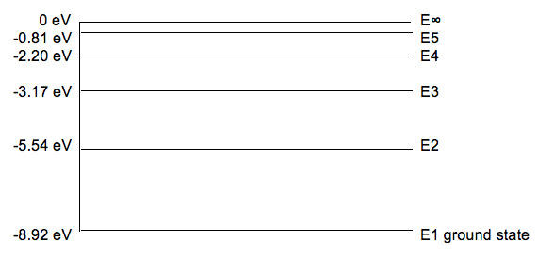

(a) Is it possible for this atom to absorb a 6.50 eV photon whilst in the ground state? Explain briefly.

(1 mark)

(b) Whilst in the ground state, the atom absorbs a 6.72 eV photon. How many lines in the emission spectrum would be possible as the atom de-excites? Indicate them on the diagram.

(1 mark)

Number of lines =

(c) Calculate the longest wavelength possible in the emission spectrum when an atomic electron at E4 can de-excite by one or more steps to ground level.

(3 marks)

(d) For the wavelength you calculated in part (c), state which area of the electromagnetic spectrum this belongs.

(1 mark)

A **single** atom in the ground state is bombarded by **one** electron with a kinetic energy of 6.10 eV.

(e) Detail in the table below the possible photon energies observable on de-excitation and the possible bombarding electron energies after its interactions with the atom. (3 marks)

|  |  |
| --- | --- |
| Possible photon energies on de-excitation (eV) | Possible bombarding electron energy after interaction with the atom (eV) |
|  |  |

(f) Explain briefly how analysis of a line absorption spectrum of light from distant galaxies can be used to determine the composition of stars and gas clouds.

(2 marks)

(g) The line absorption spectrum is also useful to determine the speed of a galaxy. Explain the fundamental principles of this technique.

(2 marks)